Name: Palak Pandey Mark /50

# Brief introduction /3

My feature for the Corsair Clash game is the enemy readout and details about the enemy.

When a player hits the enemy, they will see details about the enemy. My job is to create the pop-up dialogue box which gives details about the enemy including their strength and damage.

# Use case diagram with scenario __/14

## Use Case Diagrams

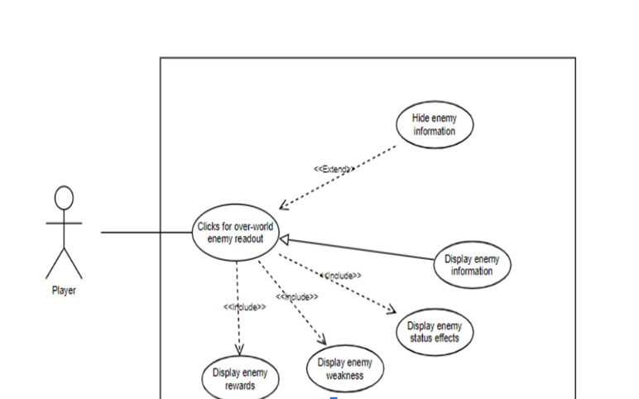

Use Case Diagram : Player gets details of the enemy.

## Scenarios

## Scenario 1 (First Use Case Diagram):

**Name:** Enemy Detail

**Summary:** The player gets details about the enemy

**Actors:** The Player

**Preconditions:** A player has started the sail and hit the enemy

## Basic sequence:

**Step 1:** Player starts to sail in the overworld map.

**Step 2:** Player sees the enemy ship and hits the ship.

**Step 3:** A pop up dialogue box appears with the details of the enemy.

**Step 4:** Player looks at all the details of the match.

**Step 5:** Player clicks the start war button.

**Step 6:** The battle scenes start.

## Exceptions:

**Step 1:** Player decides to find another enemy and clicks the close button.

**Step 2:** Player gets back in the overworld and looks for other enemies.

**Post conditions:** Player is in the battle scene.

## Priority: 1*

**ID:** F01

# Data Flow diagram(s) from Level 0 to process description for your feature 14

# In the data flow diagram below, the enemy readout feature data flow is showcased connected to the overworld load scene. The subprocesses in this feature are Find a enemy and decide whether to fight or not.

**Data Flow Diagram**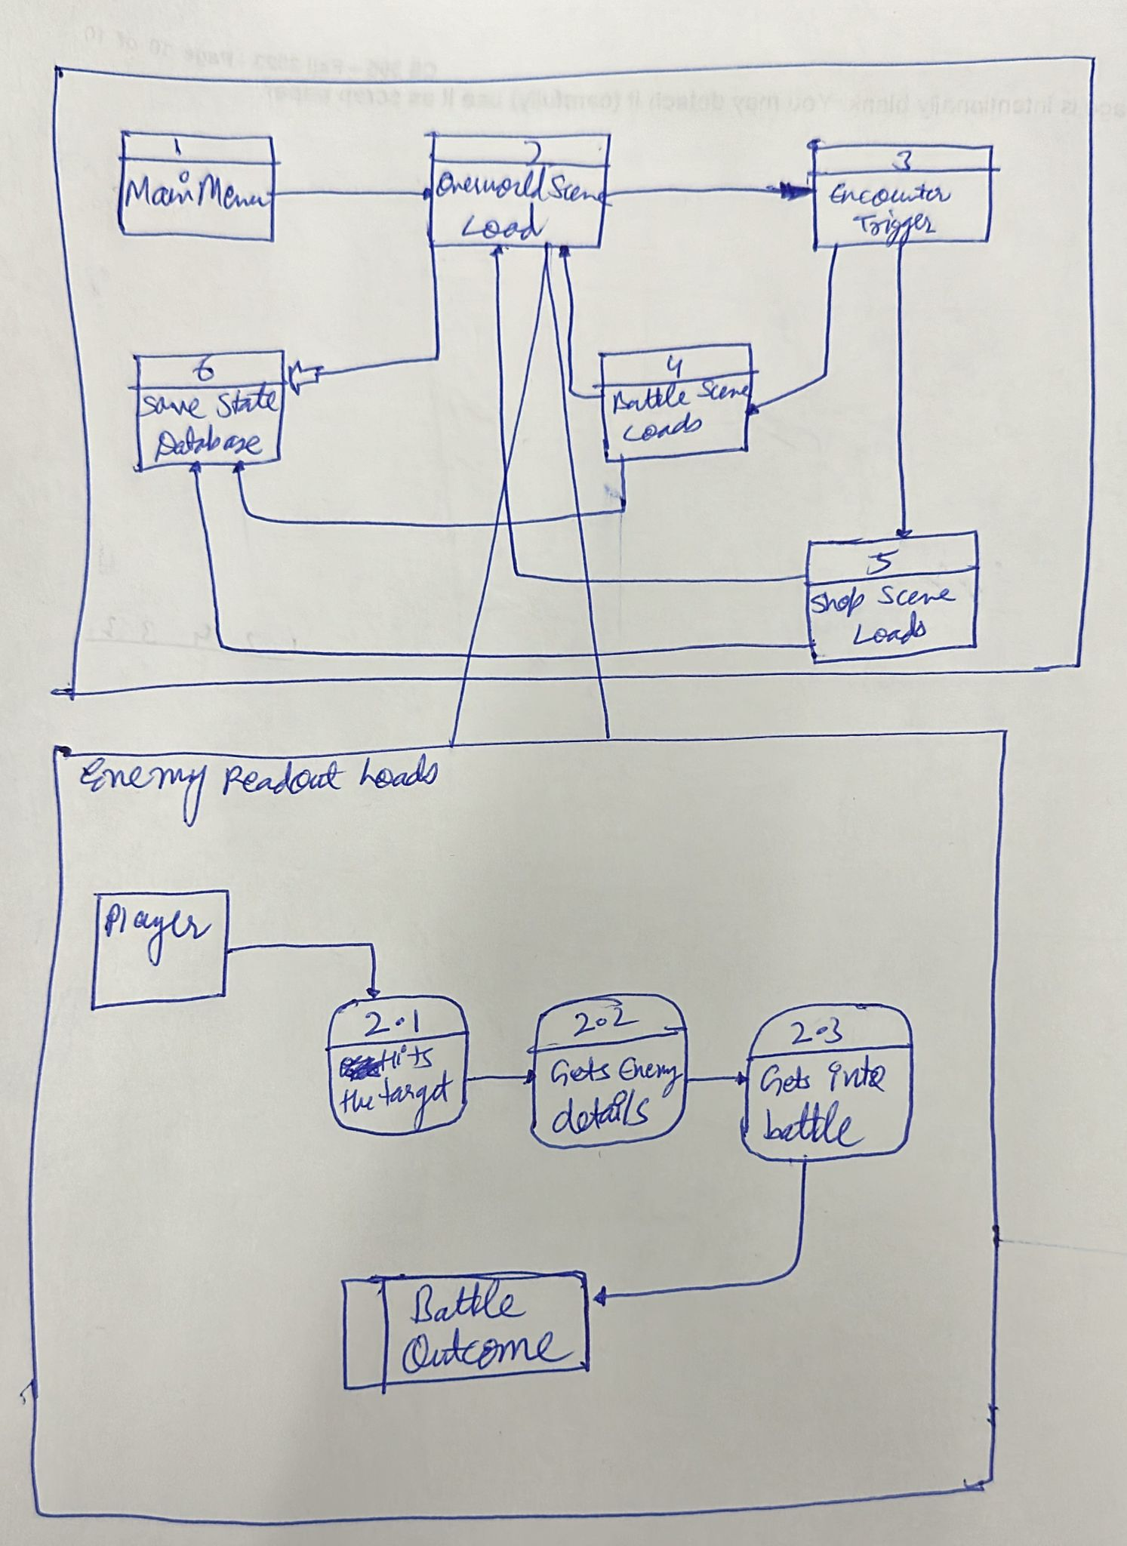

**Process Descriptions**

**WHILE player is in Overworld map**

**THEN player hits the enemy**

**IF player hits the enemy**

**THEN A pop out screen comes with enemy details.**

**IF player decides to battle, he clicks on the start battle button**

**END IF**

**ELSE player decides to go back to overworld map he clicks close information button.**

**END ELSE**

**END IF**

**ELSE**

**Player continues to sail in the overworld map.**

**END ELSE**

**END WHILE**

# Acceptance Tests 9

Considering that a user might hit two or more ships together at the same time, the test will revolve around it.

Input: Player hitting 10 enemy ships at the same time.

Output:

* Max number of enemy details dialogue box: 4
* Min number of enemy details dialogue box: 1
* No same enemy details dialogue box appears more than 1
* Considering 4 dialogue boxes together will appear at the same time no dialogue box should appear more than 4 times.

## Example

|  |  |  |
| --- | --- | --- |
| Actor Type | Appearance on screen (no of times) | Notes |
| Box 1 | 1 | Can be revisited by clicking back |
| Box 2 | 2 |  |
| Box 3 | 3 |  |
| Box 4 | 4 | Stays on the screen until player is ready to see ship no. 8’s details. |
| Box 5 | 4 |  |

# Timeline /10

**Work items**

|  |  |  |
| --- | --- | --- |
| Task | Duration (PWks) | Predecessor Task(s) |
| 1. Creating dialouge box | 6 | - |

|  |  |  |
| --- | --- | --- |
| 2. Making them dynamic | 4 | 1 |
| 3. Getting the details of the AI enemies ship | 2 | 1,2 |
| 4. Adding the enemy manager to the different dailouge boxes | 4 | 3 |
| 5.Creating click arrow to move forward or back | 2 | 4 |
| 6. Setting testing boundaries | 3 | 5 |
| 7. Testing | 5 | 6 |
| 8. User Documentation | 3 | 7 |
| 9. Installation into Game | 5 | 7,8 |
|  |  |  |
|  |  |  |

**Pert diagram**

**Gantt timeline:**

